CSC 352 / 452: Database Programming
subprograms

6. Subprograms
Procedures and functions are named blocks. They are also known as subprograms. These subprograms are compiled and stored in the database.

The following table shows the differences between anonymous blocks and subprograms.

Anonymous Blocks | Subprograms
Unnamed PL/SQL blocks | Named PL/SQL blocks
Compiled every time | Compiled only once
Not stored in the database | Stored in the database
Cannot be invoked by other applications | Named and, therefore, can be invoked by other  applications
Do not return values | Subprograms called functions must return values
Cannot take parameters | can take parameters

6.1 Procedure

A procedure has a header, an optional declarative section, an executable section, and an optional exception-handling section.

You create new procedures with the CREATE PROCEDURE statement, which may declare a list of parameters and must define the actions to be performed by the standard PL/SQL block.

CREATE [OR REPLACE] PROCEDURE procedure_name
[(parameter [{IN | OUT | IN OUT}] datatype [{:= | DEFAULT} expression],
......
parameter [{IN | OUT | IN OUT}] datatype [{:= | DEFAULT} expression])]
{IS | AS}
[declaration statements]
BEGIN
executable statements
[EXCEPTION
exception handler statements]
END [procedure_name];

Example

CREATE OR REPLACE PROCEDURE my_proc0
AS
BEGIN
DBMS_OUTPUT.PUT_LINE('Hello World!');
END my_proc0;

-------------------------------------------------------------
EXEC my_proc0

-------------------------------------------------------------

You can call this procedure from a PL/SQL block as follows:

BEGIN
my_proc0;
END;

Example

CREATE OR REPLACE PROCEDURE my_proc1(
p_p1 IN NUMBER)
AS
v_1 NUMBER;
BEGIN
v_1 := p_p1 * 100;
DBMS_OUTPUT.PUT_LINE(v_1);
END my_proc1;

-------------------------------------------------------------
EXEC my_proc1(40)

Note that when an invalid PL/SQL subprogram is detected by SQL Developer, the status is indicated with a red X over the icon for the subprogram in the System Navigator.

You may use the SHOW ERROR command to find compilation errors.

6.1.1 Parameters (IN, OUT and IN OUT)
Parameters are used to transfer data values between the calling environment and the procedure (or subprogram). Parameters are also known as arguments. Parameters are declared in the subprogram header, after the name and before the declaration section for local variables.

IN | OUT | IN OUT
The default. | Must be specified. | Must be specified.
Passes value to a subprogram. | Returns values to the caller. | Passes initial values to a subprogram, returns updated values to the caller.
Formal parameter acts like a constant. | Formal parameter acts like an uninitialized variable. | Formal parameter acts like an initialized variable.
Formal parameter cannot be assigned a value. | Formal parameter cannot be used in an expression; must be assigned a value. | Formal parameter should be assigned a value.
Actual parameter can be a constant, initialized variable, literal, or expression. | Actual parameter must be a variable. | Actual parameter must be a variable.

1) An IN parameter lets you pass values to the subprogram being called. Inside the subprogram, an IN parameter acts like a constant. It cannot be assigned a value. You can pass a constant, literal, initialized variable, or expression as an IN parameter. IN parameters can be initialized to default values, which are used if those parameters are omitted from the subprogram call. The default mode is IN.

Example

CREATE OR REPLACE PROCEDURE my_proc2(
p_p1 IN NUMBER,
p_p2 NUMBER)
AS
v_1 NUMBER;
BEGIN
v_1 := p_p1 + p_p2;
DBMS_OUTPUT.PUT_LINE(v_1);
END my_proc2;
-------------------------------------------------------------

EXEC my_proc2(10, 40);

2) An OUT parameter returns a value to the caller of a subprogram. Inside the subprogram, an OUT parameter acts like a variable. You can change its value, and reference the value after assigning it. You must pass a variable, not a constant or an expression, to an OUT parameter. Like variables, OUT formal parameters are initialized to NULL. Before exiting a subprogram, assign values to all OUT formal parameters. Otherwise, the corresponding actual parameters will be null. If you exit successfully, PL/SQL assigns values to the actual parameters. If you exit with an unhandled exception, PL/SQL does not assign values to the actual parameters.

Example

CREATE OR REPLACE PROCEDURE my_proc3(
p_p1 IN NUMBER,
p_p2 OUT NUMBER)
AS
BEGIN
p_p2 := p_p1 * 100;
END my_proc3;
-------------------------------------------------------------

DECLARE
v_1 NUMBER;
BEGIN
my_proc3(20, v_1);
DBMS_OUTPUT.PUT_LINE(v_1);
END;

3) An IN OUT parameter passes initial values to a subprogram and returns updated values to the caller. It can be assigned a value and its value can be read. Typically, an IN OUT parameter is a string buffer or numeric accumulator, that is read inside the subprogram and then updated. The actual parameter that corresponds to an IN OUT formal parameter must be a variable; it cannot be a constant or an expression. If you exit a subprogram successfully, PL/SQL assigns values to the actual parameters. If you exit with an unhandled exception, PL/SQL does not assign values to the actual parameters.

Example

CREATE OR REPLACE PROCEDURE my_proc4(
p_p1 IN NUMBER,
p_p2 IN OUT NUMBER,
p_p3 OUT NUMBER) AS

BEGIN
p_p2 := p_p1 + p_p2;
p_p3 := p_p1 * p_p2;
END my_proc4;
-------------------------------------------------------------

DECLARE
v_1 NUMBER;
v_2 NUMBER;
v_3 NUMBER;
BEGIN
v_1 := 10;
v_2 := 100;
my_proc4(v_1, v_2, v_3);
DBMS_OUTPUT.PUT_LINE
('v_1 = ' || v_1 || ', v_2 = ' || v_2 || ', v_3 = ' || v_3);
END;

6.1.2 Constraints on Formal Parameters

In a procedure declaration, it is illegal to constrain CHAR and VARCHAR2 parameters with length, and NUMBER parameters with a precision and/or scale. The constraints on formal parameters come from the actual parameters.

Example

CREATE OR REPLACE PROCEDURE my_proc5(
p_p1 IN OUT VARCHAR2(50),
p_p2 IN OUT NUMBER(3, 2)) AS
BEGIN
p_p1 := '1bcdefghijklmo';
p_p2 := 12.3;
END my_proc5;

(It will generate a compiler error.)

6.1.3 Default Values

We can define a default value for any IN parameter. OUT and IN OUT parameters cannot be defaulted.

Example

CREATE OR REPLACE PROCEDURE my_proc6(
p_p1 IN VARCHAR2,
p_p2 IN VARCHAR2 DEFAULT 'PL/SQL') AS
BEGIN
DBMS_OUTPUT.PUT_LINE (p_p1 || ' ' || p_p2);
END my_proc6;

-------------------------------------------------------------

BEGIN
my_proc6('Oracle', 'SQL');
my_proc6('Oracle');
END;

-------------------------------------------------------------

EXEC my_proc6('Oracle', 'SQL');

-------------------------------------------------------------

Example

CREATE OR REPLACE PROCEDURE disp_avg_sal(p_department_id NUMBER DEFAULT 0)
AS
v_avg_sal NUMBER(7, 2);
BEGIN
IF p_department_id = 0 THEN
SELECT AVG(salary)
INTO v_avg_sal
FROM employee;
ELSE
SELECT AVG(salary)
INTO v_avg_sal
FROM employee
WHERE department_id = p_department_id;
END IF;

IF v_avg_sal IS NOT NULL THEN
DBMS_OUTPUT.PUT_LINE (v_avg_sal);
ELSE
DBMS_OUTPUT.PUT_LINE ('N/A');
END IF;
END;

-------------------------------------------------------------

BEGIN
disp_avg_sal();
disp_avg_sal(20);
disp_avg_sal(99);
END;

-------------------------------------------------------------

6.1.4 Position and Named Notation

- As the name implies, positional notation passes parameters based on their position in the parameter list, regardless of name.
- With named notation, the programmer specifically assigns a value to a named parameter; the order in which the parameters appear does not matter.

Example

CREATE OR REPLACE PROCEDURE my_proc7(
a NUMBER DEFAULT 0,
b NUMBER DEFAULT 0,
c NUMBER DEFAULT 0) AS
BEGIN
DBMS_OUTPUT.PUT_LINE (a * 100 + b * 10 + c);
END my_proc7;

1) You call the procedure using positional notation by

BEGIN
my_proc7(3, 5, 1);
END;

2) You call the procedure using named notation by

BEGIN
my_proc7(c => 1, b => 5, a => 3);
END;

3) You call the procedure using a mix of both positional and named notation

BEGIN
my_proc7(3, b => 5, c => 1);
END;

There is a restriction on mixed notation. All positional notation actual parameters must occur first in the same order as they are defined by the procedure (function) signature. You cannot provide a position value after a named value. For example, the following procedure call is illegal:

BEGIN
my_proc7(a => 10, 20, 5); -- illegal
END;

Error report:
……
PLS-00312: a positional parameter association may not follow a named
association

Example

CREATE OR REPLACE PROCEDURE my_proc8(
a NUMBER DEFAULT 10,
b NUMBER,
c NUMBER DEFAULT 30) AS
BEGIN
DBMS_OUTPUT.PUT_LINE (a * 100 + b * 10 + c);
END my_proc8;

-------------------------------------------------------------

BEGIN
my_proc8(b => 20);
END;
-------------------------------------------------------------

BEGIN
my_proc8(1, 20);
END;

-------------------------------------------------------------

BEGIN
my_proc8(b =>20, c => 1);
END;

-------------------------------------------------------------

BEGIN
my_proc8(c =>1, b => 20);
END;

-------------------------------------------------------------

Example

PROCEDURE add_employee()

CREATE OR REPLACE PROCEDURE add_employee
(
p_employee_id NUMBER,
p_employee_name VARCHAR2 DEFAULT NULL,
p_job VARCHAR2 DEFAULT NULL,
p_manager_id NUMBER DEFAULT NULL,
p_hire_date DATE DEFAULT NULL,
p_salary NUMBER DEFAULT 0,
p_commission NUMBER DEFAULT 0,
p_department_id NUMBER,
p_ret_code OUT NUMBER,
p_ret_message OUT VARCHAR2
) AS
v_count NUMBER;
BEGIN
SELECT COUNT(*)
INTO v_count
FROM employee
WHERE employee_id = p_employee_id;

IF v_count <> 0 THEN
p_ret_code := -1;
p_ret_message := 'The employee_id (' || p_employee_id ||
') is in the employee table.';
RETURN;
END IF;

SELECT COUNT(*)
INTO v_count
FROM department
WHERE department_id = p_department_id;

IF v_count = 0 THEN
p_ret_code := -1;
p_ret_message := 'The department_id (' || p_department_id ||
') is not in the department table.';
RETURN;
END IF;

INSERT INTO employee
(
EMPLOYEE_ID,
EMPLOYEE_NAME,
JOB,
MANAGER_ID,
HIRE_DATE,
SALARY,
COMMISSION,
DEPARTMENT_ID)
VALUES
(
p_employee_id,
UPPER(p_employee_name),
UPPER(p_job),
p_manager_id,
p_hire_date,
p_salary,
p_commission,
p_department_id);
COMMIT;
p_ret_code := 1;
p_ret_message := 'OK.';
EXCEPTION
WHEN OTHERS THEN
p_ret_code := SQLCODE;
p_ret_message := SQLERRM;
END;

Testing procedure add_employee()

DECLARE
v_code NUMBER;
v_message VARCHAR2(100);
BEGIN
add_employee(9901, 'TERRY', 'SALEMAN', 7698, '08-SEP-08',
2000, 0, 30, v_code, v_message);
DBMS_OUTPUT.PUT_LINE('ret_code = ' || TO_CHAR(v_code));
DBMS_OUTPUT.PUT_LINE('ret_message = ' || v_message);

add_employee (9902, 'FORD', p_department_id => 30,
p_ret_code => v_code, p_ret_message => v_message);
DBMS_OUTPUT.PUT_LINE('ret_code = ' || TO_CHAR(v_code));
DBMS_OUTPUT.PUT_LINE('ret_message = ' || v_message);

add_employee (9903, 'CHAN', 'SALEMAN', 7698, '10-SEP-08',
2000, 0, 30, v_code, v_message);
DBMS_OUTPUT.PUT_LINE('ret_code = ' || TO_CHAR(v_code));
DBMS_OUTPUT.PUT_LINE('ret_message = ' || v_message);

add_employee (9904, 'WARD', 'SALEMAN', 7698, '20-SEP-08',
2000, 0, 99, v_code, v_message);
DBMS_OUTPUT.PUT_LINE('ret_code = ' || TO_CHAR(v_code));
DBMS_OUTPUT.PUT_LINE('ret_message = ' || v_message);
END;

6.2 Function

Functions and procedures are structured alike. A function must return a value to the calling environment, whereas a procedure returns zero or more values to its calling environment through OUT parameters.

Like a procedure, a function has a header, a declarative section, an executable section, and an optional exception-handling section. A function must have a RETURN clause in the header and at least one RETURN statement in the executable section.

CREATE [OR REPLACE] FUNCTION function_name
[(parameter [{IN | OUT | IN OUT}] datatype [{:= | DEFAULT} expression],
…
parameter [{IN | OUT | IN OUT}] datatype [{:= | DEFAULT} expression])]
RETURN datatype
{IS | AS}
[declaration statements]
BEGIN
executable statements
[EXCEPTION
exception handler statements]
END [name];

6.2.1 Return Values
From within your function, at any point in the body, you simply code a

RETURN <expression>;

where the expression evaluates to the RETURN data type of the function itself.

Every exit point needs a RETURN <expression> statement.

Example

CREATE OR REPLACE FUNCTION find_area
(p_length IN NUMBER, p_width IN NUMBER) RETURN NUMBER
AS
v_area NUMBER;
BEGIN
v_area := p_length * p_width;
RETURN v_area;
END find_area;

-------------------------------------------------------------

DECLARE
v_area NUMBER;
BEGIN
v_area := find_area(10, 45);
DBMS_OUTPUT.PUT_LINE('Area = ' || TO_CHAR(v_area));
END;
--------------------------------------------------------------

SELECT find_area(10, 45) FROM dual;

Example

CREATE OR REPLACE FUNCTION my_func0(
p_p1 NUMBER,
p_p2 NUMBER)
RETURN NUMBER
AS
BEGIN
RETURN p_p1 + p_p2;
END my_func0;

--------------------------------------------------------------

SELECT my_func0(1, 2) FROM dual;

In Oracle Database 10g, if you issue the following statement:

SELECT my_func0(p_p1=>1, p_p2=>2) FROM dual;

You will get the error:

ERROR at line 1:
ORA-00907: missing right parenthesis

In Oracle Database 11g, you are free to use this notation:

SELECT my_func0(p_p1=>1, p_p2=>2) FROM dual;

Example

CREATE OR REPLACE FUNCTION check_input_employee_id
(
p_employee_id IN VARCHAR2
)
RETURN NUMBER
AS
v_input VARCHAR2(100);
BEGIN
v_input := trim(p_employee_id);

IF v_input IS NULL THEN
RETURN -1;
END IF;
FOR i IN 1..length(v_input) LOOP
IF SUBSTR(v_input, i, 1) > '9' OR
SUBSTR(v_input, i, 1) < '0' THEN
RETURN -1;
END IF;
END LOOP;
RETURN 1;
END;

--------------------------------------------------------------
ACCEPT p_1 PROMPT 'Please enter the employee_id:'

DECLARE
v_emp_id VARCHAR2(100) := '&p_1';
v_count NUMBER;
BEGIN
IF check_input_employee_id(v_emp_id) = -1 THEN
DBMS_OUTPUT.PUT_LINE('Invalid employee_id');
ELSE
SELECT COUNT(*)
INTO v_count
FROM employee
WHERE employee_id = TO_NUMBER(v_emp_id);

IF v_count = 0 THEN
DBMS_OUTPUT.PUT_LINE(v_emp_id || ' is not in the table.');
ELSE
DBMS_OUTPUT.PUT_LINE(v_emp_id || ' is in the table.');
END IF;
END IF;
END;

Example

Function display_employee()

First, we need to create a new object type (user-defined composite data type) that contains the fields that are going to be returned.

CREATE OR REPLACE TYPE emp_col AS OBJECT (
EMPLOYEE_ID NUMBER(4),
EMPLOYEE_NAME VARCHAR2(10),
JOB VARCHAR2(50),
MANAGER_ID NUMBER(4),
HIRE_DATE DATE,
SALARY NUMBER(9, 2),
COMMISSION NUMBER(9, 2),
DEPARTMENT_ID NUMBER(4));

Then, out of the new type, a nested table type must be created.

CREATE OR REPLACE TYPE t_emp_table AS TABLE OF emp_col;

CREATE OR REPLACE FUNCTION display_employee (
p_employee_id NUMBER DEFAULT 0)
RETURN t_emp_table AS
v_ret t_emp_table;
BEGIN
IF p_employee_id = 0 THEN
SELECT emp_col
(
employee_id,
employee_name,
job,
manager_id,
hire_date,
salary,
commission,
department_id
)
BULK COLLECT INTO v_ret FROM employee
ORDER BY employee_id;
ELSE
SELECT emp_col
(
employee_id,
employee_name,
job,
manager_id,
hire_date,
salary,
commission,
department_id
)
BULK COLLECT INTO v_ret FROM employee
WHERE employee_id = p_employee_id
ORDER BY employee_id;
END IF;
RETURN v_ret;
END;

Testing function display_emp()

SELECT * FROM TABLE(display_employee());
SELECT * FROM TABLE(display_employee(7698));

6.3 Exceptions Raised Inside Subprograms

If an error occurs inside a subprogram, an exception is raised.

Example

CREATE OR REPLACE PROCEDURE my_proc8
(p_employee_id IN NUMBER, p_employee_name OUT VARCHAR2) AS
BEGIN
SELECT employee_name
INTO p_employee_name
FROM employee
WHERE employee_id = p_employee_id;
EXCEPTION
WHEN OTHERS THEN
p_employee_name:= 'N/A';
END my_proc8;

--------------------------------------------------------------

DECLARE
v_ename employee.employee_name%TYPE;
BEGIN
My_proc8(1000, v_ename);
DBMS_OUTPUT.PUT_LINE('v_ename = ' || v_ename);
END;

If the procedure has no exception handler for this occur, control immediately passes out of the procedure to the calling environment, in accordance with the exception propagation rules. However, in this case, the values of OUT and IN OUT formal parameters are not return to the actual parameters. The actual parameters will have the same values as they would have the procedure not been called.

Example

CREATE OR REPLACE PROCEDURE my_proc9
(p_data OUT NUMBER) AS
v_1 NUMBER;
BEGIN
p_data := 999;

v_1 := 100 / 0;

p_data := 1000;
END my_proc9;

--------------------------------------------------------------

DECLARE
v_num NUMBER;
BEGIN
v_num := -1;
my_proc9(v_num);
DBMS_OUTPUT.PUT_LINE('1 My output: ' || TO_CHAR(v_num));
EXCEPTION
WHEN OTHERS THEN
DBMS_OUTPUT.PUT_LINE('2 My output: ' || TO_CHAR(v_num));
END;

--------------------------------------------------------------

Example

CREATE OR REPLACE PROCEDURE my_proc10
(p_data OUT NUMBER) AS
v_1 NUMBER;
BEGIN
p_data := 999;

v_1 := 100 / 0;

p_data := 1000;
EXCEPTION
WHEN OTHERS THEN
NULL;
END my_proc10;

--------------------------------------------------------------

DECLARE
v_num NUMBER;
BEGIN
v_num := -1;
my_proc10(v_num);
DBMS_OUTPUT.PUT_LINE('1 My output: ' || TO_CHAR(v_num));
EXCEPTION
WHEN OTHERS THEN
DBMS_OUTPUT.PUT_LINE('2 My output: ' || TO_CHAR(v_num));
END;

--------------------------------------------------------------

6.4 Privileges and Subprograms

EXECUTE Privilege -- For stored subprograms, the relevant privilege is EXECUTE.

Example

GRANT EXECUTE ON your_procedure TO user_name;

SELECT grantee, owner, table_name, grantor, privilege
FROM user_tab_privs;

REVOKE EXECUTE ON your_procedure FROM user_name;

6.5 Dropping Procedures and Functions

DROP PROCEDURE procedure_name;
DROP FUNCTION function_name;

6.6 Subprogram Locations

SELECT object_name, object_type, last_ddl_time, status
FROM user_objects
WHERE object_name = 'MY_PROC1'; -- UPPERCASE

SELECT text
FROM user_source
WHERE name = 'MY_PROC1'
ORDER BY line;

6.7 Wrapping PL/SQL Code with DBMS_DDL.CREATE_WRAPPED Procedure

The DBMS_DDL.CREATE_WRAPPED procedure is used to create and wrap a procedure, function, package specification, package body, type specification, or type body.

DECLARE
v_ddl VARCHAR2(500);
BEGIN
v_ddl := 'CREATE OR REPLACE PROCEDURE my_proc88 AS ' ||
'BEGIN DBMS_OUTPUT.PUT_LINE(''CSC 452''); END;';
DBMS_DDL.CREATE_WRAPPED(v_ddl);
END;

When you check the data dictionary view USER_SOURCE , the source is wrapped, or hidden, so that others cannot view the code details. For example:

SELECT text
FROM user_source
WHERE name = 'MY_PROC88'
ORDER BY line;

The resulting output is similar to the following:

TEXT
-----------------------------------
PROCEDURE my_proc88 wrapped
a000000
b2
abcd
abcd
abcd
abcd
……

6.8 Optional Topic – Nested Procedures and Functions

You can define procedures/functions in any PL/SQL block, procedure/function, or package.

- The procedure/function must go at the end of the DECLARATION section, after all other items.
- You must declare a procedure/function before calling it.
- You can declare interrelated nested procedure/function using a forward declaration; a procedure/function spec terminated by a semicolon, with no body.

Example

DECLARE
v_first_number NUMBER;
v_second_number NUMBER;

PROCEDURE swap_num
(p_num_one IN OUT NUMBER, p_num_two IN OUT NUMBER) IS
v_temp_num NUMBER;
BEGIN
v_temp_num := p_num_one;
p_num_one := p_num_two;
p_num_two := v_temp_num ;
END;

BEGIN
v_first_number := 10;
v_second_number := 20;

swap_num(v_first_number, v_second_number);

DBMS_OUTPUT.PUT_LINE
('First Number = ' || to_CHAR (v_first_number));
DBMS_OUTPUT.PUT_LINE
('Second Number = ' || to_CHAR (v_second_number));
END;

Example

CREATE OR REPLACE FUNCTION fun_nested(p_some_date DATE)
RETURN VARCHAR2 IS
v_year_str VARCHAR2(4);

-- beginning of nested function in declaration section

FUNCTION turn_around (p_year VARCHAR2)
RETURN VARCHAR2 IS
BEGIN
v_year_str := TO_CHAR(TO_NUMBER(p_year)*2);
RETURN v_year_str;
END;
-- end of nested function in declaration section

BEGIN
v_year_str := TO_CHAR(p_some_date, 'YYYY');
v_year_str := turn_around(v_year_str);
RETURN v_year_str;
END fun_nested;

----------------------------------------------------
SELECT fun_nested('01-DEC-1998') FROM dual;

Example

DECLARE
v_n NUMBER;

PROCEDURE proc_1 (p_1 VARCHAR2) IS
BEGIN
DBMS_OUTPUT.PUT_LINE('proc1: ' || p_1);
END;

PROCEDURE proc_2 (p_1 VARCHAR2) IS
BEGIN
DBMS_OUTPUT.PUT_LINE('proc2: ' || p_1);
END;

BEGIN
SELECT COUNT(*)
INTO v_n
FROM department;

DBMS_OUTPUT.PUT_LINE(v_n);
proc_1('A');
proc_2('B');
END;

Example

DECLARE
v_n NUMBER;
PROCEDURE proc_1 (p_1 VARCHAR2); -- forward declaration

PROCEDURE proc_2 (p_1 VARCHAR2) IS
BEGIN
proc_1('from proc_2'); -- calls proc_1
END;

PROCEDURE proc_1 (p_1 VARCHAR2) IS
BEGIN
DBMS_OUTPUT.PUT_LINE('proc1: ' || p_1);
END;
BEGIN
SELECT COUNT(*)
INTO v_n
FROM department;

DBMS_OUTPUT.PUT_LINE(v_n);
proc_1('A');
proc_2('B');
END;

6.9 Optional Topic - Understanding the NOCOPY Parameter Mode Hint

PL/SQL offers an option for definitions of parameters: the NOCOPY clause. NOCOPY is a hint to the compiler about how you would like the PL/SQL engine to work with the data structure being passed in as an OUT or IN OUT parameter.

To understand NOCOPY and its potential impact, it will help to review how PL/SQL handles parameters. Let’s start with definitions:

- Formal parameter – The parameter defined in the parameter list and used in the program.

- Actual parameter – The actual expression or variable passed to the program when it is called.

- By value – When an actual parameter passed by value, the value of the actual parameter is copied into the corresponding formal parameter. If the program then terminates without an exception, the formal parameter value is copied back to the actual parameter. If an error occurs, the changed values are not copied back to the actual parameter.

- By reference – When an actual parameter is passed by reference, it means that a pointer to the actual parameter is passed to the corresponding formal parameter. Both the actual and formal parameters then reference, or point to, the same location in memory that holds the value of the parameter.

Parameter passing in PL/SQL follows the rules shown in the following table.

Parameter Mode | Default | NOCOPY
IN | By reference | N/A
OUT | By value | By reference
IN OUT | By value | By reference

With the BY VALUE method, the value of an actual parameter is passed to the subprogram. With the BY REFERENCE method, only a pointer to the value is passed, the actual and formal parameters reference the same item.

Example

CREATE OR REPLACE PROCEDURE nocopy_proc
(p_data OUT NOCOPY NUMBER)
AS
v_1 NUMBER;
BEGIN
p_data := 999;
END nocopy_proc;

--------------------------------------------------------------

Depending on your application, NOCOPY can improve the performance of programs with OUT or IN OUT parameters. As you might expect, these potential gains only available with a trade-off: if a program terminates with an unhandled exception, you cannot trust the values in a NOCOPY actual parameter.

Example

CREATE OR REPLACE PROCEDURE copy_proc
(p_1 IN OUT NUMBER, p_2 IN OUT NUMBER) AS
v_1 NUMBER;
BEGIN
p_1 := 100;
v_1 := 1 / 0;
p_2 := 200;
END copy_proc;

--------------------------------------------------------------

DECLARE
v_1 NUMBER := 1;
v_2 NUMBER := 2;
BEGIN
copy_proc(v_1, v_2);
DBMS_OUTPUT.PUT_LINE('(by value) v_1 = ' || TO_CHAR(v_1));
DBMS_OUTPUT.PUT_LINE('(by value) v_2 = ' || TO_CHAR(v_2));
EXCEPTION
WHEN OTHERS THEN
DBMS_OUTPUT.PUT_LINE('(by value - Error) v_1 = ' || TO_CHAR(v_1));
DBMS_OUTPUT.PUT_LINE('(by value - Error) v_2 = ' || TO_CHAR(v_2));
END;

--------------------------------------------------------------

CREATE OR REPLACE PROCEDURE nocopy_proc
(p_1 IN OUT NOCOPY NUMBER, p_2 IN OUT NOCOPY NUMBER)
AS
v_1 NUMBER;
BEGIN
p_1 := 100;
v_1 := 1 / 0;
p_2 := 200;
END nocopy_proc;

--------------------------------------------------------------

DECLARE
v_1 NUMBER := 1;
v_2 NUMBER := 2;
BEGIN
nocopy_proc(v_1, v_2);
DBMS_OUTPUT.PUT_LINE('(by ref) v_1 = ' || TO_CHAR(v_1));
DBMS_OUTPUT.PUT_LINE('(by ref) v_2 = ' || TO_CHAR(v_2));
EXCEPTION
WHEN OTHERS THEN
DBMS_OUTPUT.PUT_LINE('(by ref - Error) v_1 = ' || TO_CHAR(v_1));
DBMS_OUTPUT.PUT_LINE('(by ref - Error) v_2 = ' || TO_CHAR(v_2));
END;

--------------------------------------------------------------

Aliasing (that is, having two different names refer to the same memory location) can occur when the same actual parameter appears more than once in a subprogram call.

Example

CREATE OR REPLACE PROCEDURE aliasing_proc
(p_1 IN NUMBER, p_2 IN OUT NUMBER, p_3 IN OUT NOCOPY NUMBER) AS
BEGIN
p_2 := 200;
DBMS_OUTPUT.PUT_LINE('(1) p_1 = ' || TO_CHAR(p_1));
p_3 := 300;
DBMS_OUTPUT.PUT_LINE('(2) p_1 = ' || TO_CHAR(p_1));
END aliasing_proc;

--------------------------------------------------------------

DECLARE
v_1 NUMBER := 10;
v_2 NUMBER := 20;
v_3 NUMBER := 30;
BEGIN
aliasing_proc(v_1, v_2, v_3);
DBMS_OUTPUT.PUT_LINE('v_1 = ' || TO_CHAR(v_1));
DBMS_OUTPUT.PUT_LINE('v_2 = ' || TO_CHAR(v_2));
DBMS_OUTPUT.PUT_LINE('v_3 = ' || TO_CHAR(v_3));
END;

--------------------------------------------------------------

DECLARE
v_1 NUMBER := 20;
BEGIN
aliasing_proc(10, v_1, v_1);
DBMS_OUTPUT.PUT_LINE('v_1 = ' || TO_CHAR(v_1));
END;

--------------------------------------------------------------

DECLARE
v_1 NUMBER := 20;
BEGIN
aliasing_proc(v_1, v_1, v_1);
DBMS_OUTPUT.PUT_LINE('v_1 = ' || TO_CHAR(v_1));
END;

6.10 Optional Topic – Creating functions to join and split strings

When you select data from a database, you may need to format the output as a comma delimited list. Another task is to do the reverse.

For example, all employee names are separated by commas.

ADAMS,CLARK,FISHER,JACKSON,JONES,JOST,KING,LANCASTER,LEE,MILLER,SCOTT,SMITH,STEEL,WILSON,WOLFE

The following examples show you how to create functions to join and split strings.

Example

CREATE OR REPLACE FUNCTION my_join
(
p_cursor SYS_REFCURSOR, -- Ref Cursor
p_delimiter VARCHAR2 := ','
)
RETURN VARCHAR2
AS
v_value VARCHAR2(4000);
v_return_string VARCHAR2(4000);
BEGIN
LOOP
FETCH p_cursor INTO v_value;
EXIT WHEN p_cursor%NOTFOUND;

IF v_return_string IS NOT NULL THEN
v_return_string := v_return_string || p_delimiter;
END IF;

v_return_string := v_return_string || v_value;
END LOOP;
RETURN v_return_string;
END;

--------------------------------------------------------------

The following statement uses the default delimiter (“,”).

SELECT my_join(CURSOR(SELECT employee_name
FROM employee
ORDER BY employee_name)) AS ENAME
FROM dual;

Oracle Database SQL Reference:
A CURSOR expression (CURSOR(subquery)) is equivalent to the PL/SQL REF CURSOR and can be passed a REF CURSOR argument to a function.

You can use any data type in the cursor as long as it's one column.

SELECT my_join(CURSOR(SELECT hire_date FROM employee),'|') FROM dual;

Since the cursor is part of the SQL statement, you can easily join the query inside the my_join with the outer query.

SELECT department_name,
my_join(CURSOR
(SELECT employee_name
FROM employee
WHERE department_id =
department.department_id
ORDER BY employee_name
)
) Employees
FROM department
ORDER BY department_name;

Example

CREATE OR REPLACE type split_table_type AS TABLE OF VARCHAR2(4000);

CREATE OR REPLACE FUNCTION my_split
(
p_list VARCHAR2,
p_delimiter VARCHAR2 := ','
)
RETURN split_table_type
AS
v_idx NUMBER;
v_list VARCHAR2(4000) := p_list;
v_return_tab split_table_type;

BEGIN
v_return_tab := split_table_type();
LOOP
v_idx := INSTR(v_list, p_delimiter);
v_return_tab.EXTEND;
IF v_idx > 0 THEN
v_return_tab(v_return_tab.COUNT) :=
SUBSTR(v_list, 1, v_idx-1);
v_list := SUBSTR(v_list, v_idx + LENGTH(p_delimiter));
ELSE
v_return_tab(v_return_tab.COUNT) := v_list;
EXIT;
END IF;
END LOOP;
RETURN v_return_tab;
END;

Oracle Database SQL Reference:
The INSTR (string, substring [, position [, occurrence]]) function searches string for substring. The function returns an integer indicating the position of the character in string that is the first character of this occurrence.
The SUBSTR (string, position, [, substring_length]) functions return a portion of string, beginning at character position, substring_length characters long.

--------------------------------------------------------------

SELECT * FROM TABLE(my_split('one,two,three'));

--------------------------------------------------------------

CREATE TABLE my_log (id NUMBER, message VARCHAR2(4000));

INSERT INTO my_log
VALUES(1, 'Procedures and functions are named blocks. They are also known as subprograms. These subprograms are compiled and stored in the database. ');

INSERT INTO my_log
VALUES(1, 'Functions and procedures are structured alike. A function must return a value to the calling environment, whereas a procedure returns zero or more values to its calling environment through OUT parameters. ');

COMMIT;

SELECT column_value
FROM TABLE(my_split(my_join(CURSOR(SELECT message FROM my_log), ''), '. '));

6.11. Optional Topic - Debugging Subprograms

You can use SQL Developer to debug PL/SQL subprograms (procedures and functions).

(For security reasons, you cannot debug your PL/SQL subprograms on our database server.)

Now, we are going to debug a PL/SQL procedure with SQL Developer.

1. Create the following procedure.

CREATE OR REPLACE PROCEDURE my_emp (pMaxNum IN NUMBER) AS
v_num NUMBER;
v_ename employee.employee_name%TYPE;
v_job employee.job%TYPE;
v_sal employee.salary%TYPE;
v_count NUMBER;

CURSOR emp_cursor IS
SELECT employee_name, job, salary
FROM employee
ORDER BY employee_name DESC;
BEGIN

v_num := pMaxNum;
IF v_num <= 0 THEN
DBMS_OUTPUT.PUT_LINE('Too few requested.');
RETURN;
END IF;

SELECT COUNT(*)
INTO v_count
FROM employee;

IF v_num > v_count THEN
DBMS_OUTPUT.PUT_LINE('There are only ' || v_count || ' employees.');
RETURN;
END IF;

DBMS_OUTPUT.PUT_LINE('NAME JOB SALARY');

OPEN emp_cursor;

FETCH emp_cursor INTO v_ename, v_job, v_sal;

WHILE emp_cursor%ROWCOUNT <= v_num AND emp_cursor%FOUND LOOP
DBMS_OUTPUT.PUT_LINE(rpad(v_ename, 20) || rpad(v_job, 15) ||
lpad(TO_CHAR(v_sal), 9));

FETCH emp_cursor INTO v_ename, v_job, v_sal;
END LOOP;

CLOSE emp_cursor;

END my_emp;

2. Expand Procedures in the navigator. Note that when an invalid PL/SQL subprogram is detected by SQL Developer, the status is indicated with a red X over the icon for the subprogram in the System Navigator.

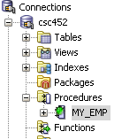

3. Right-click on MY_EMP in the left navigator and select Edit.

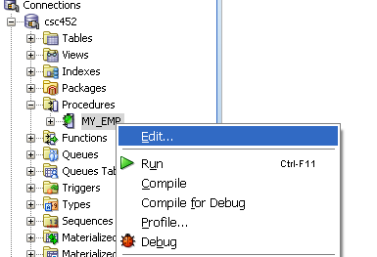

4. Set a breakpoint in the MY_EMP procedure by clicking in the margin at the line with the “OPEN emp_cursor;” statement.

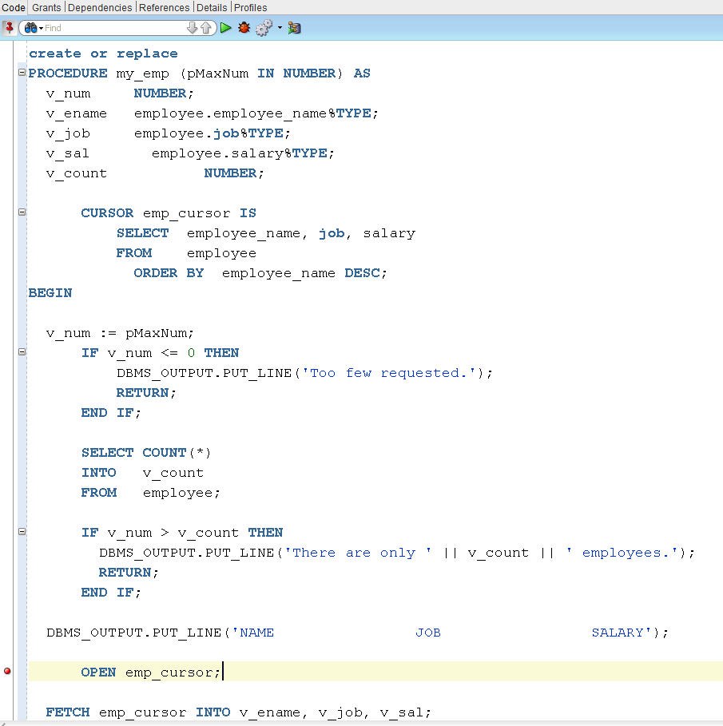
5. Click the Debug icon ().

This invokes the Debug PL/SQL dialog.
Change
pMaxNum := NULL;
to pMaxNum := 5;
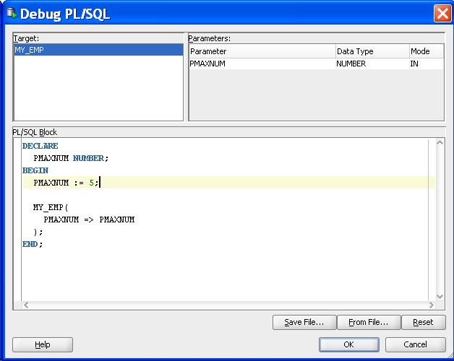

Then click OK.

6. The debugger should halt at the line where you placed the breakpoint.

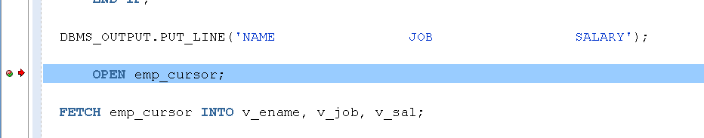

You can now control the flow of execution, modify values of variables and perform other debugging functions.

7. Click Step Into from Run or F7.

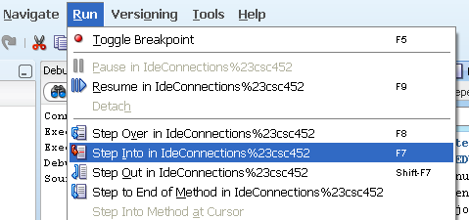

8. This takes you to the first line of the cursor.

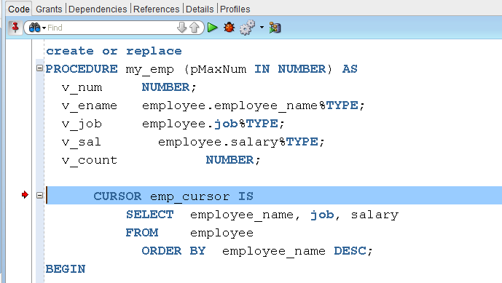

Click Step Into (F7) again.

9. You should now be selecting the first row of the cursor.

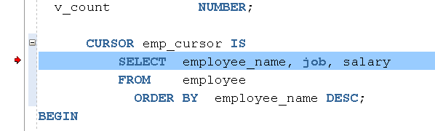

Click Step Into (F7) again.

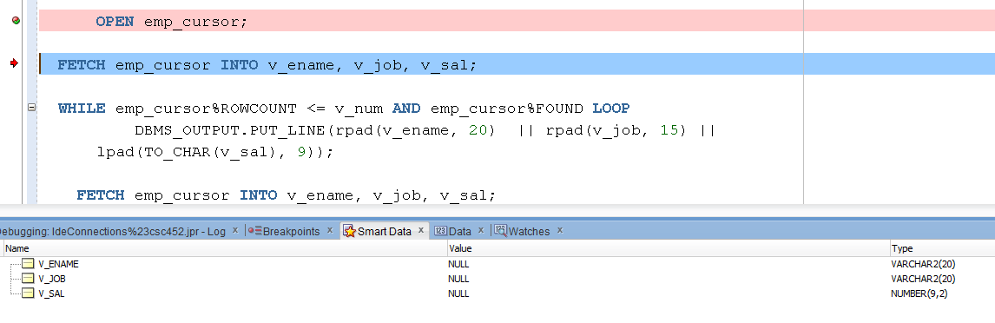

Click Step Into (F7) again.

10. The Data window starts to show a list of variables.

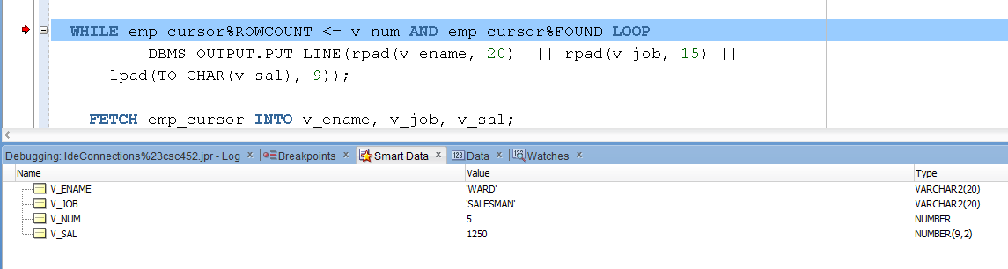

15. Click Step Into (F7) …...

